**LAB 4 LAN**

**LAB 4.1: UNDERSTANDING, CREATING AND SIMULATING PEER-TO-PEER NETWORK COMMUNICATION BY USING PACKET TRACER.**

**OBJECTIVE:** To understand the peer-to-peer connection between the device on the network

**TOOLS USED**: Packet Tracer

**BACKGROUND**: Peer-to-peer (P2P) is a decentralized communications model in which each party has the same capabilities and either party can initiate a communication session.

**TOPOLOGY:**

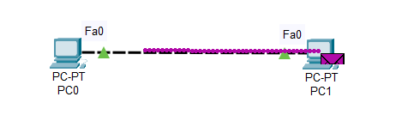

**IP address Plan**

|  |  |  |  |  |  |
| --- | --- | --- | --- | --- | --- |
| Device | Interface | IP address | Subnet Mask | VLAN | Default gateway |
| PC0 | NIC | 192.168.100.1 | 255.255.255.0 | - | - |
| PC1 | NIC | 192.168.100.2 | 255.255.255.0 | - | - |

**Procedure:**

1. First, add two computers, by going to the [End device] menu and dragging the PC icon until it looks like this:

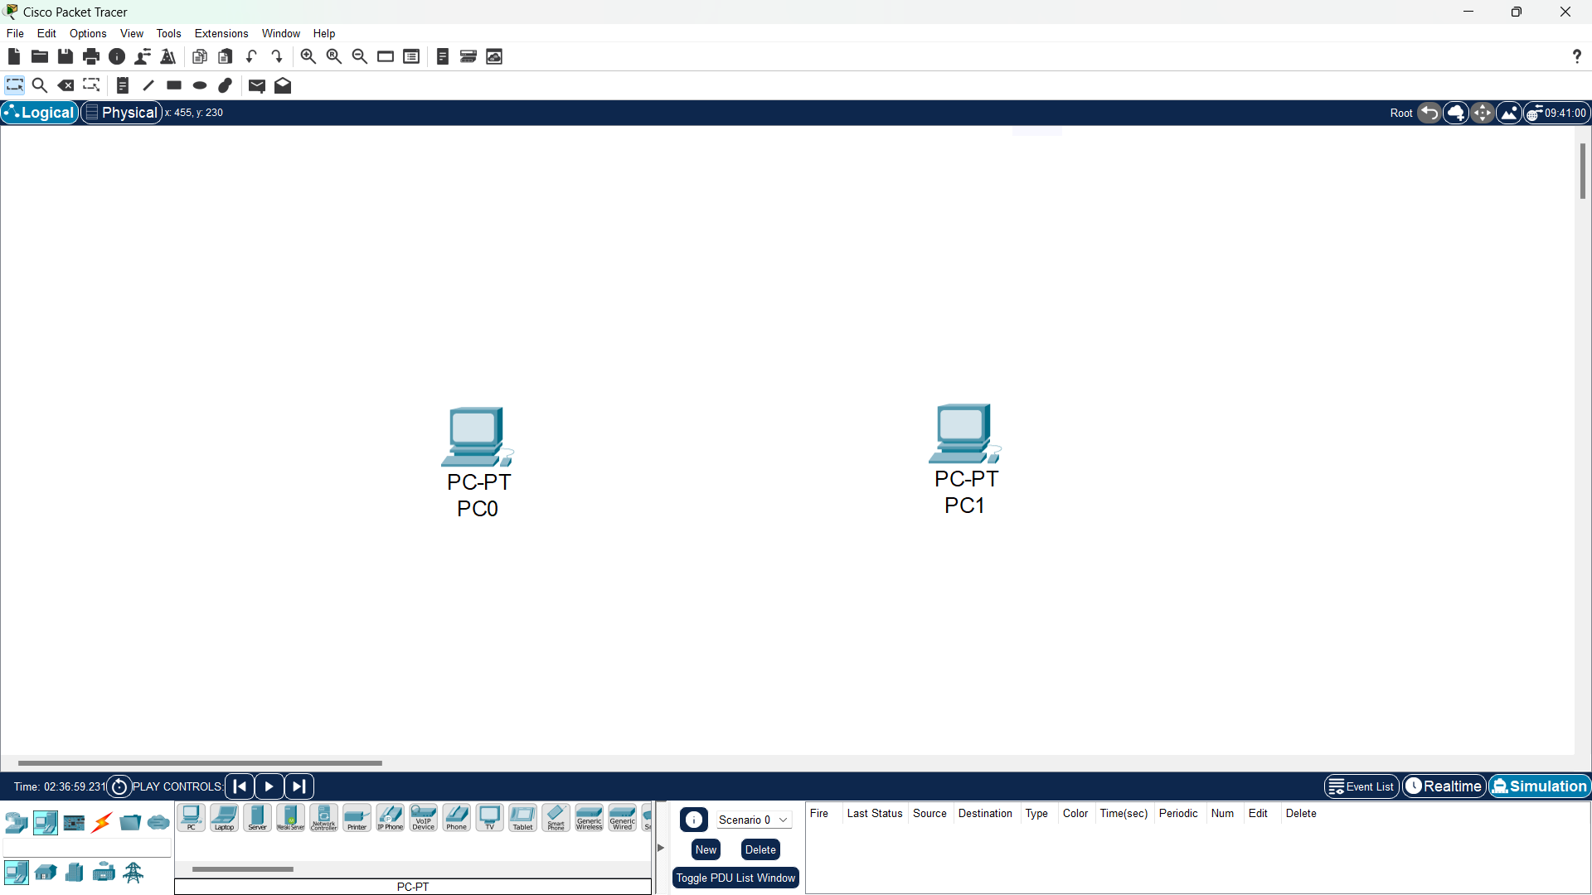

1. Then, connect the two PC using a cross-over cable or you can directly use an automatic cable so that it will look like this:

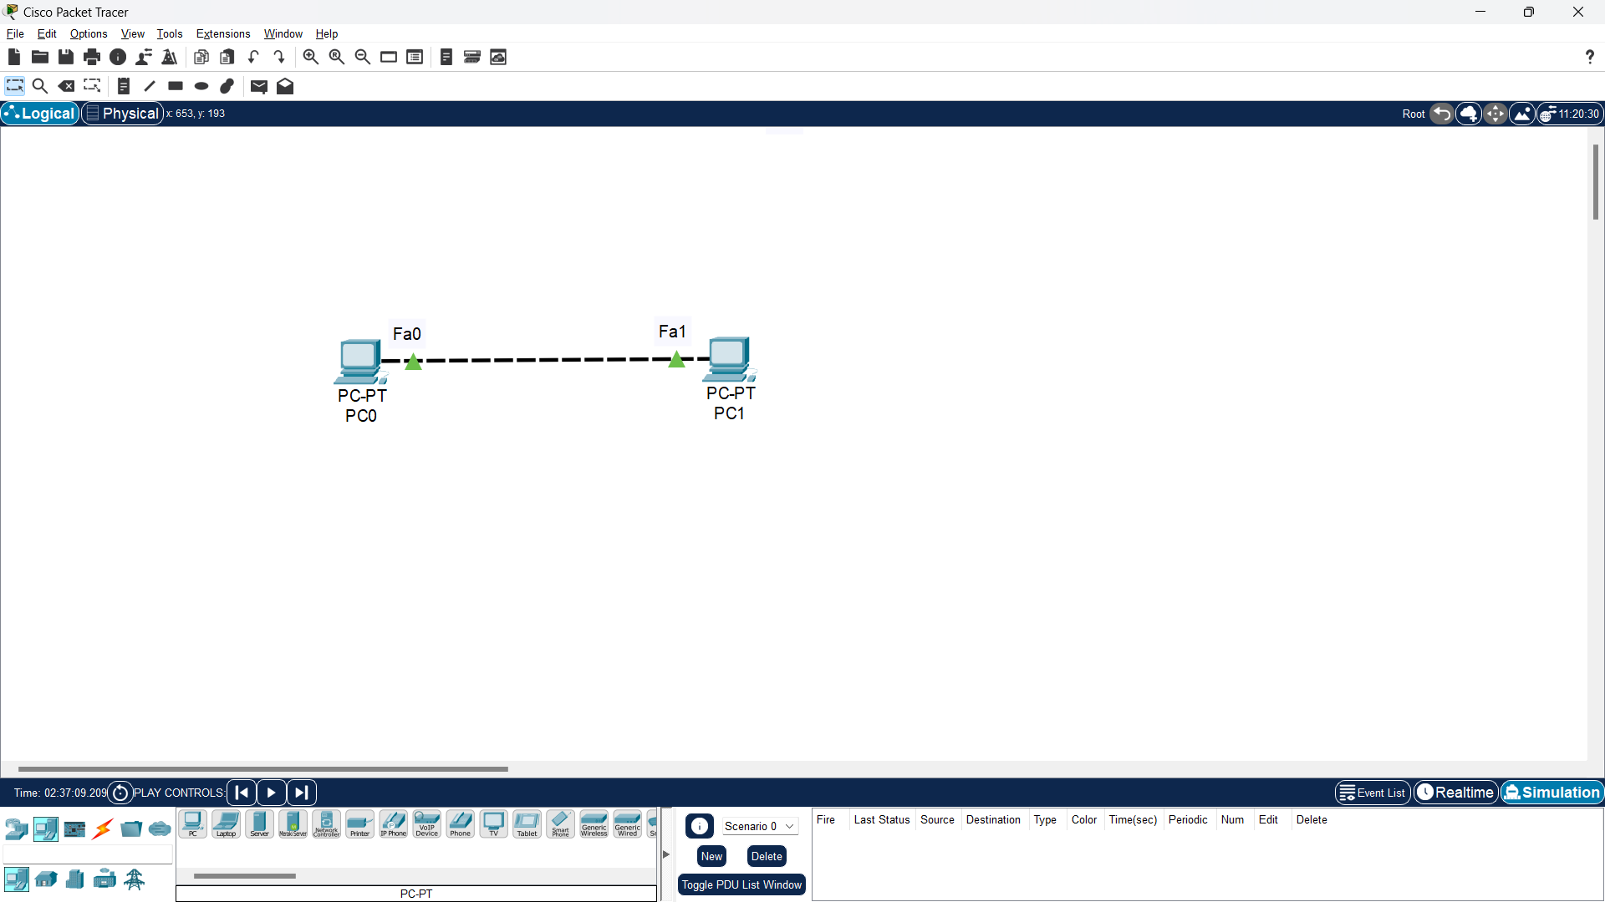

1. Then after the two PC are physically connected, the next step is to provide IP addresses to the two PCs. In this way, “click PC0 – Desktop – IP Configuration” and adjust the IP address for example:  
    a. IP address: 192.168.100.1  
    b. Subnet Mask: 255.255.255.0

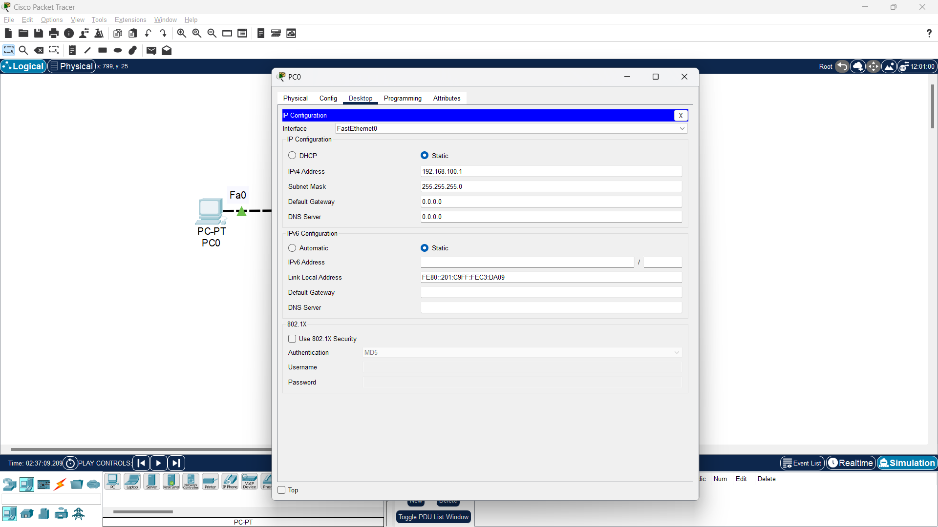

1. Do the same on another PC (PC1) with a different host IP address but on the same network for example (192.168.10.1) and subnet mask 255.255.255.0

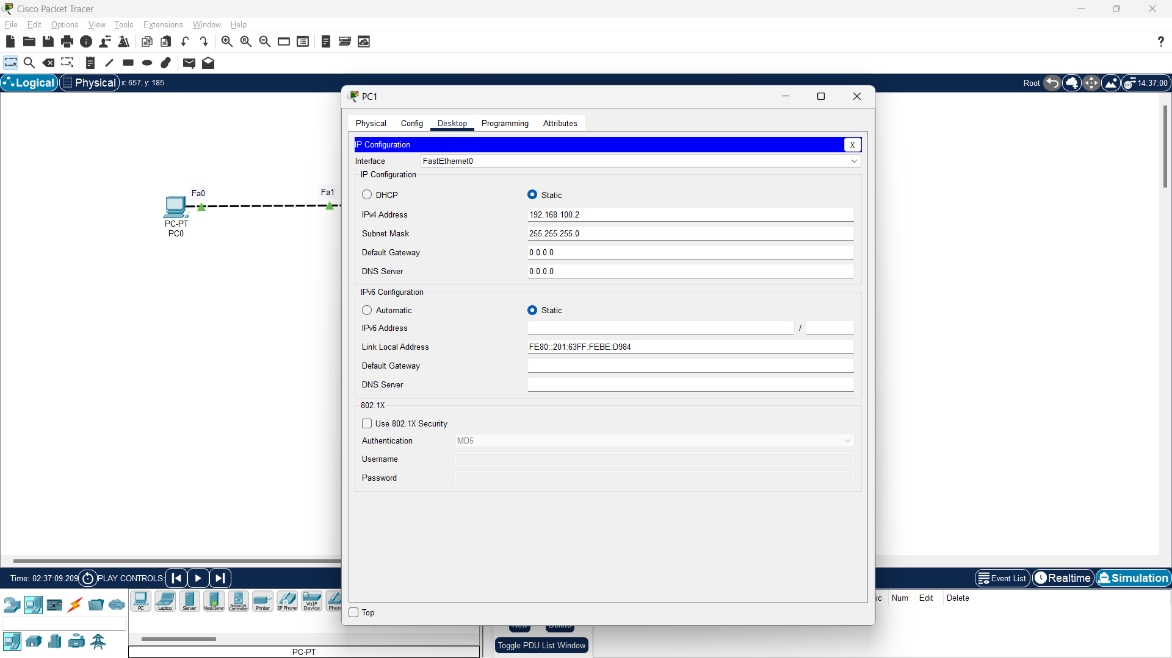

**Verification**: So, giving the IP address on the two computers will result in the two computers being able to communicate with each other, we can test this by typing ping on one computer to the IP address on the other computer. For example, we will try to test the ping from PC1 (192.168.100.2) to PC0 (192.168.100.1). To do a ping test we can use the Command Prompt on virtual computers (PC0 and PC1), by clicking on one of the computers (PC1) then go to “Command Prompt” and type:

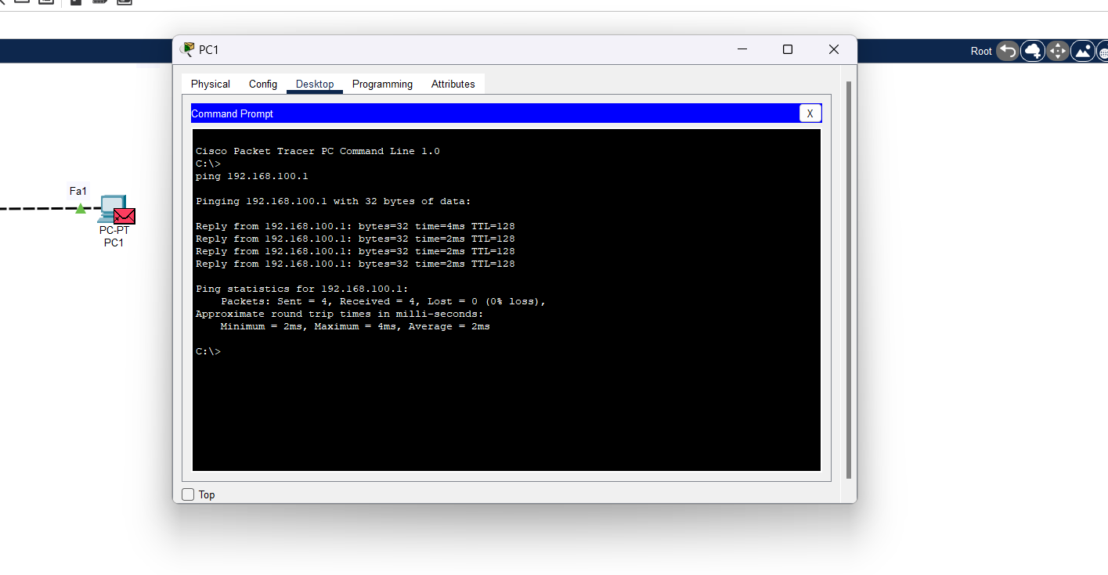

So, if indeed the two computers are connected and can communicate with each other then PC1 will send a response back with the message “reply from 192.168.100.1” which is a sign of success. However, if the process does not occur (timed out) on your display, pay attention to the IP addresses of the two computers (PC0 and PC1) must be in one segment, namely 192.168.100…..you can change the host number as long as the two hosts are different then the range of numbers that can be used is 1-255.

**Conclusion:**

In order to communication computers in a peer-to-peer network need to have assigned IP address and computers should belong to the same network.

**LAB 4.2: BUILD A LAN WITH A SWITCH AND HUB IN PACKET TRACER**

**OBJECTIVE:** To create and understand the concept of a LAN by using Switch and HUB.

**TOOLS USED**: Packet Tracer

**BACKGROUND**: A local area network (LAN) is a group of computers and peripheral devices that share a common communications line to a server within a distinct geographic area. A local area network may serve few users. In LAN nodes can communicate and share resources.

**TOPOLOGY:**

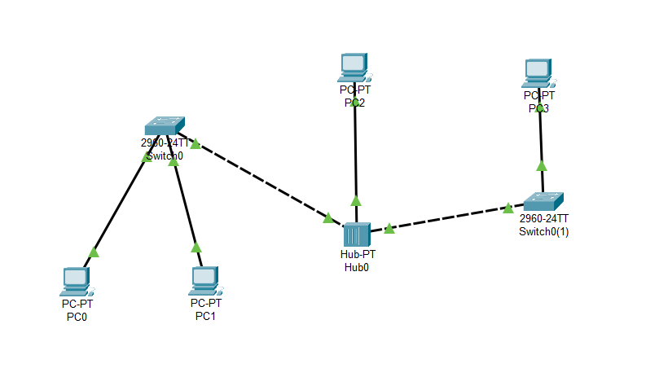

**IP Assignment Plan**

|  |  |  |  |  |  |
| --- | --- | --- | --- | --- | --- |
| Device | Interface | IP address | Subnetmask | VLAN | Default gateway |
| PC0 | NIC | 192.168.101.1 | 255.255.255.0 | - | - |
| PC1 | NIC | 192.168.101.2 | 255.255.255.0 | - | - |
| PC2 | NIC | 192.168.101.3 | 255.255.255.0 | - | - |
| PC3 | NIC | 192.168.101.4 | 255.255.255.0 | - | - |

**Procedure:**

1. First, add a HUB, two Switches and four computers, by going to the [End device] menu and dragging the components icon until it looks like this:

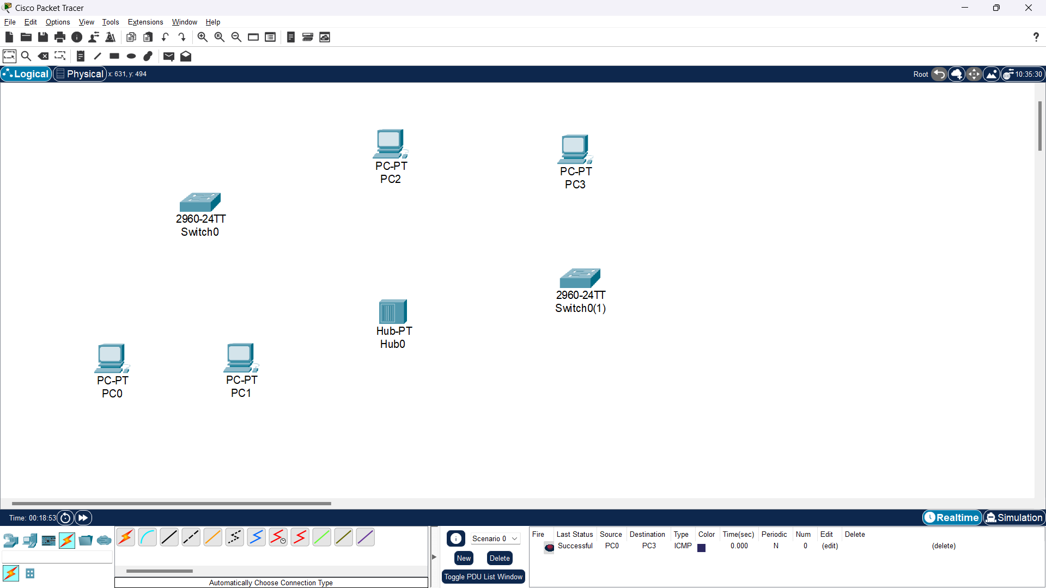

1. Then, Add the physical cabling between devices to connect the devices using automatic cable so that it will look like this:

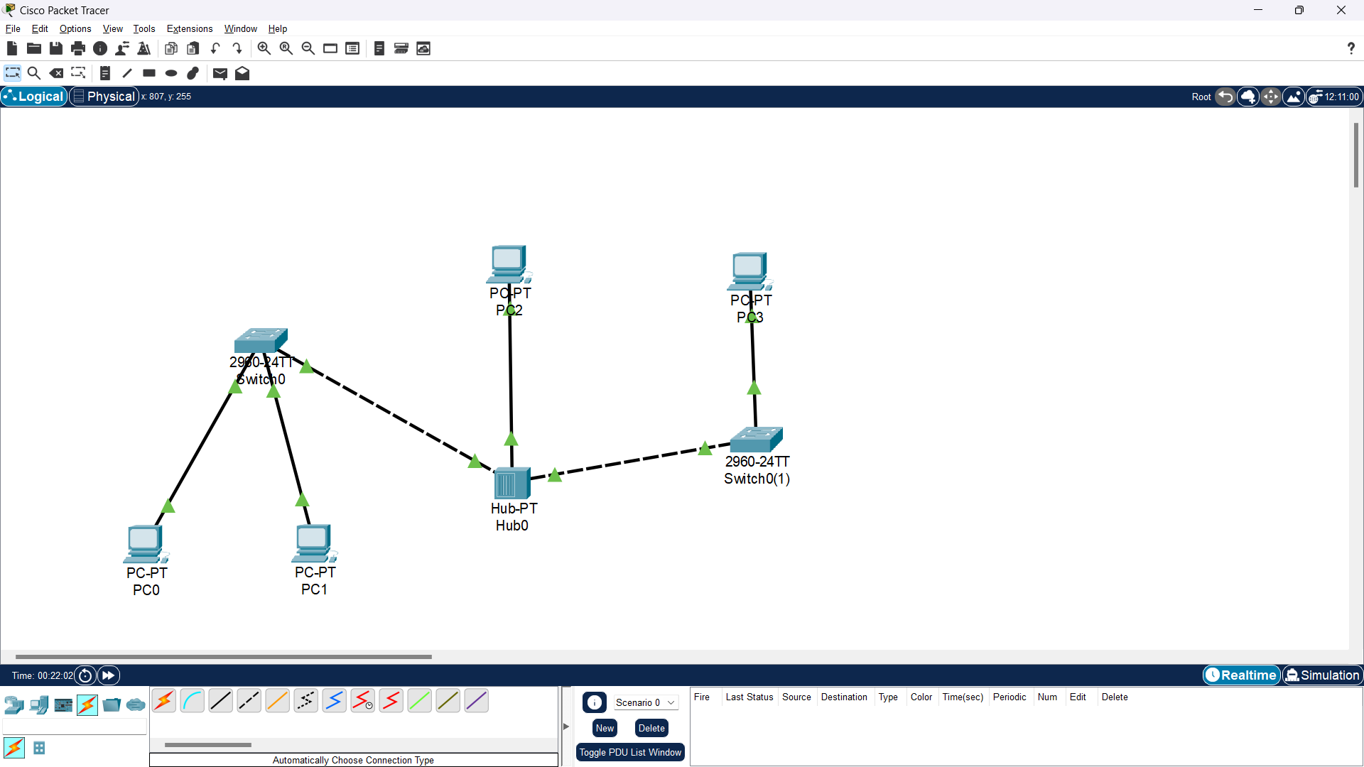

1. Then after the devices are physically connected, the next step is to configure the Devices by providing IP addresses to all the PCs. In this way, “click PC0 – Desktop – IP Configuration and adjust the IP address:

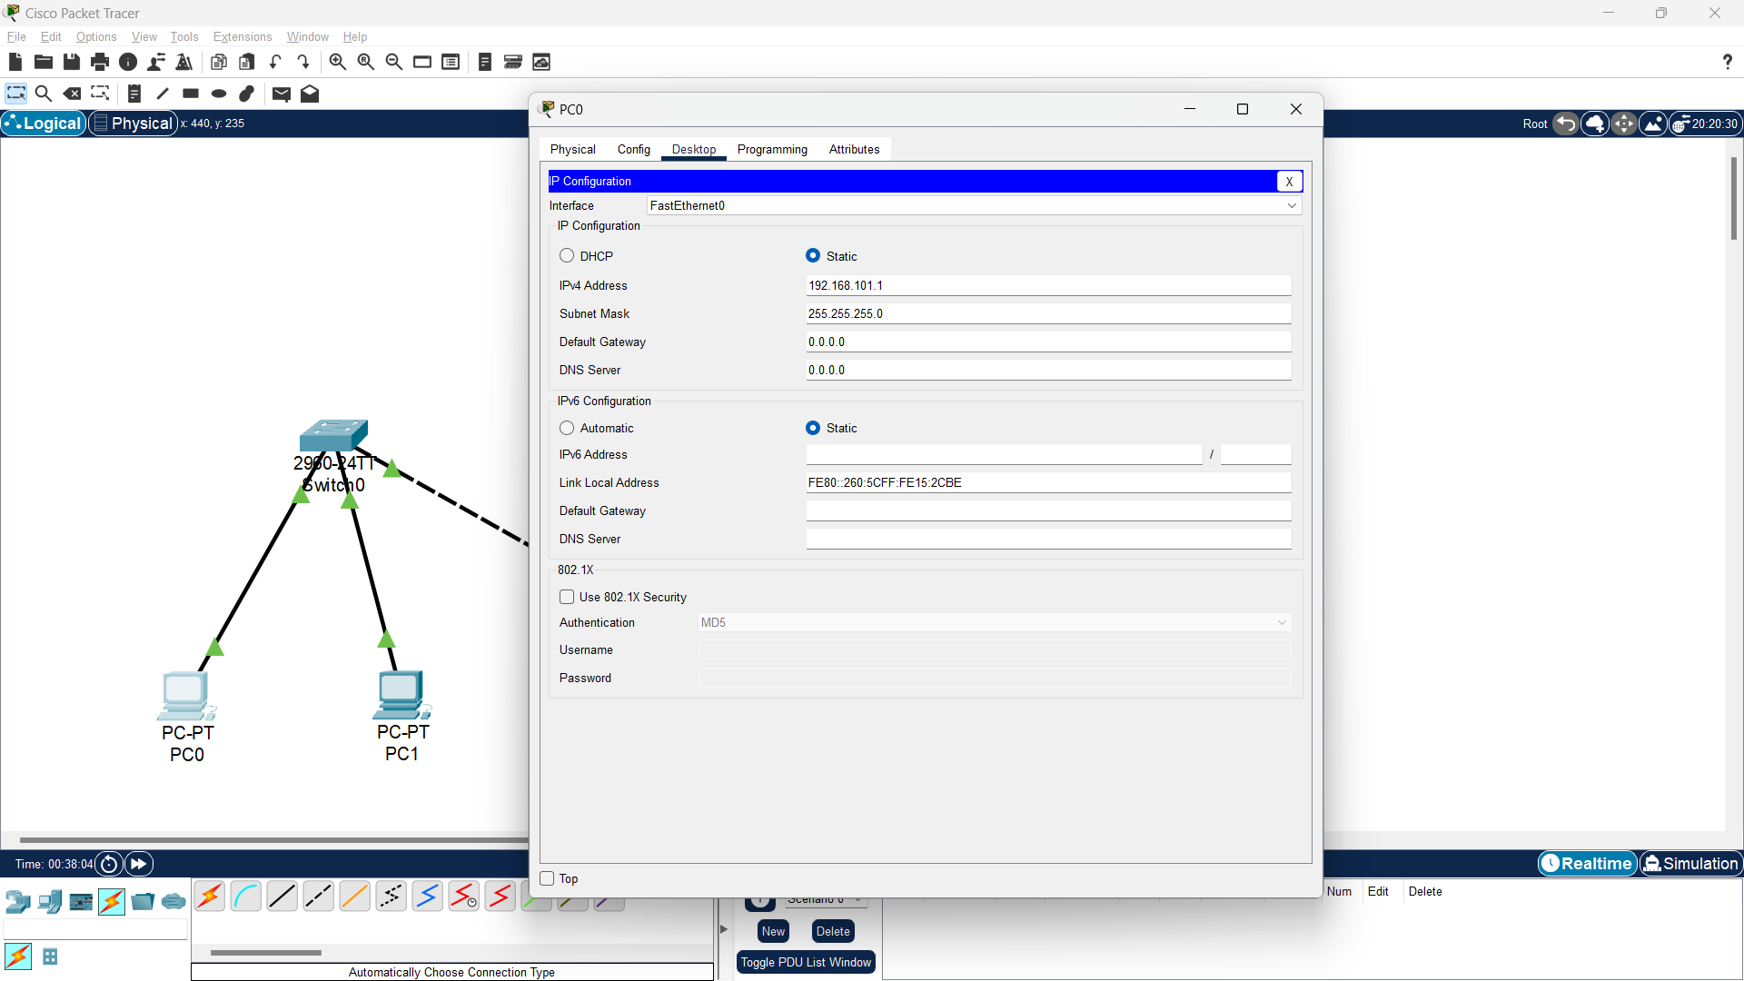

1. Do the same on other PC (PC1, PC2 & PC3) with a different host IP address but on the same network.

**Verification**: So, giving the IP address on all the computers will result in all computers being able to communicate with each other passing through different Network devices, we can test this by typing ping on one computer to the IP address on the other computers. For example, we will try to test the ping from PC0 (192.168.101.1) to PC3 (192.168.101.4). To do a ping test we can use the Command Prompt on virtual computers (PC0 and PC3), by clicking on one of the computers (PC0) then go to “Command Prompt” and type:

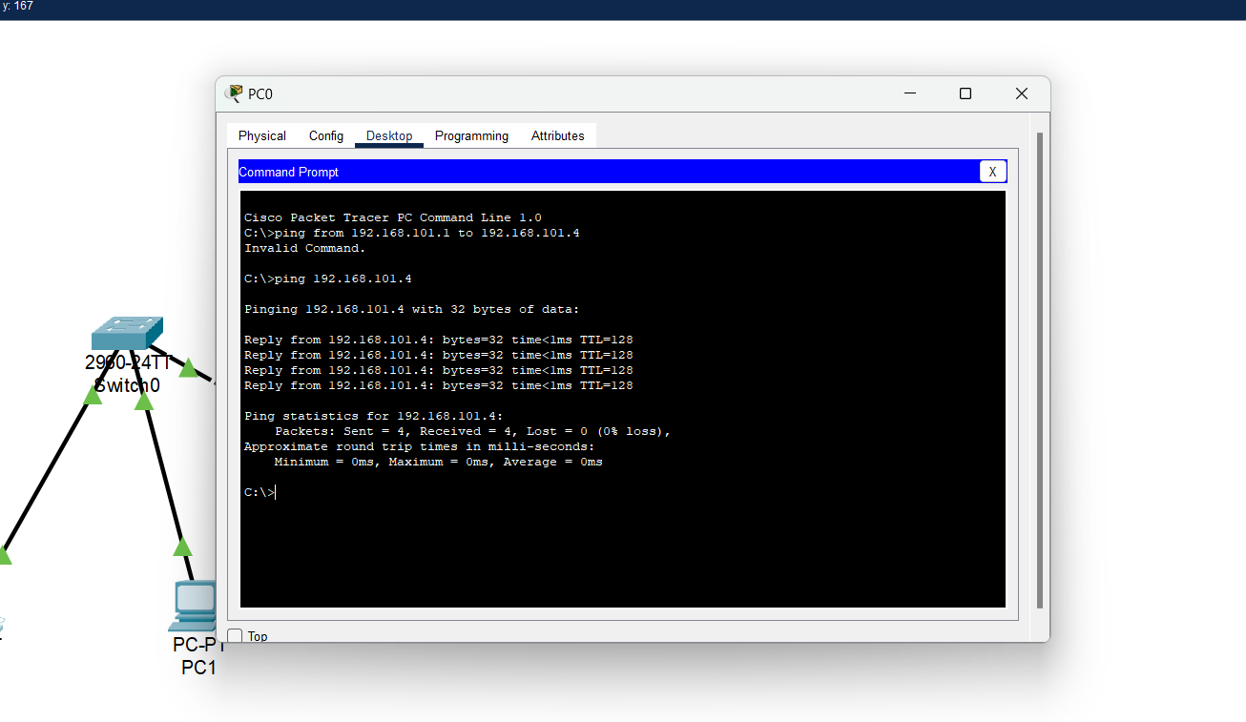

So, if indeed the computers are connected and can communicate with each other then PC3 will send a response back with the message “reply from 192.168.101.4” which is a sign of success. However, if the process does not occur (timed out) on your display, namely 192.168.101…..you can change the host number as long as the hosts are different then the range of numbers that can be used is 1-255.

**CONCLUSION:**

In order to communicate computers in a LAN, it share a common communications line to a server within a distinct geographic area.

**LAB 4.2: BUILD A WLAN WITH A SWITCH AND ACCESS POINT IN PACKET TRACER**

**OBJECTIVE:** To create and understand the concept of a WLAN by using Switch and Access Points.

**TOOLS USED**: Packet Tracer

**BACKGROUND**: A wireless LAN (WLAN) is a type of Local Area Network (LAN) that uses wireless communication to connect any type of network client or device a WLAN transmits information over radio waves. Data is sent in packets. The packets contain layers with labels and instructions that, along with the unique MAC (Media Access Control) addresses assigned to endpoints, enable routing to intended locations.

**TOPOLOGY:**

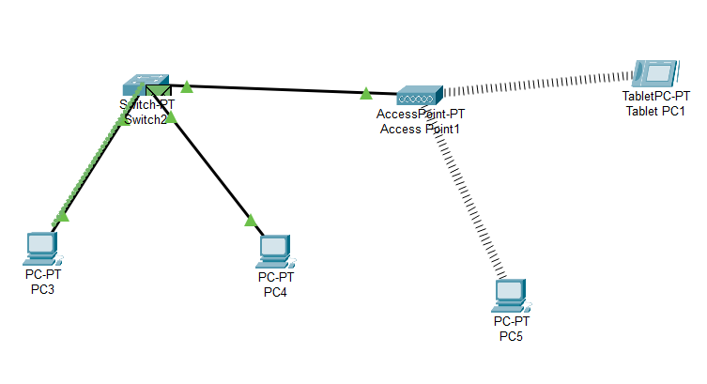

**IP assignment Plan**

|  |  |  |  |  |  |
| --- | --- | --- | --- | --- | --- |
| Device | Interface | IP address | Subnetmask | VLAN | Default gateway |
| PC3 | NIC | 192.168.1.1 | 255.255.255.0 | - | - |
| PC4 | NIC | 192.168.1.2 | 255.255.255.0 | - | - |
| PC5 | NIC | 192.168.1.3 | 255.255.255.0 | - | - |
| Tablet PC1 | NIC | 192.168.1.4 | 255.255.255.0 | - | - |

**Procedure:**

1. First, add a Switch, a Access Point, three computers and a portable computing device , by going to the [End device] menu and dragging the components icon until it looks like this:

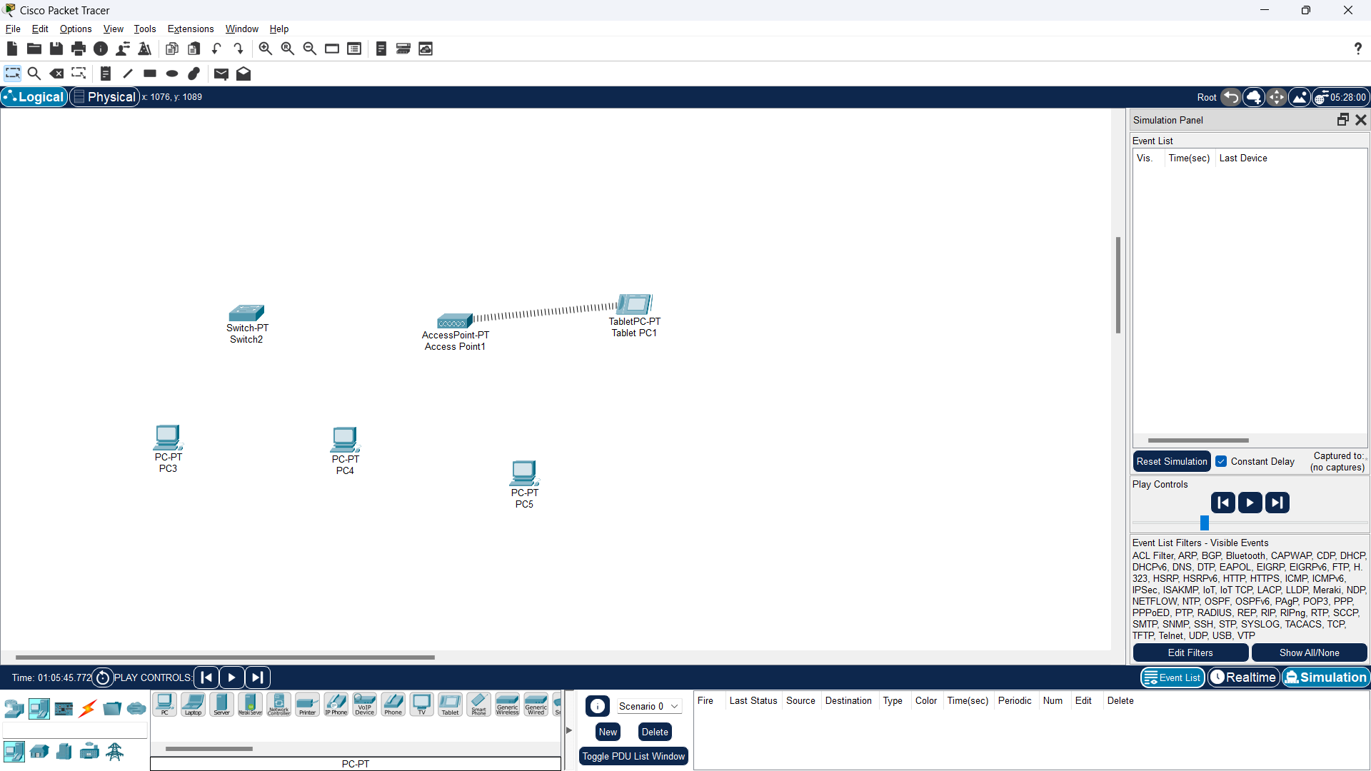

1. Then make a PC (PC5) connect wirelessly to access point. In this way, “click PC5 – Physical – Turn off pc ‘by clicking red button’– replace the present module of pc with WMP300N module – Turn ON the PC”. For example:

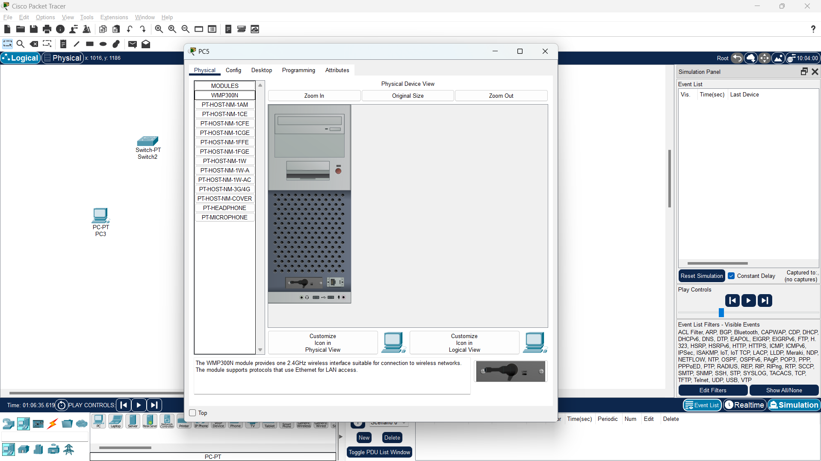

Then it look like this,

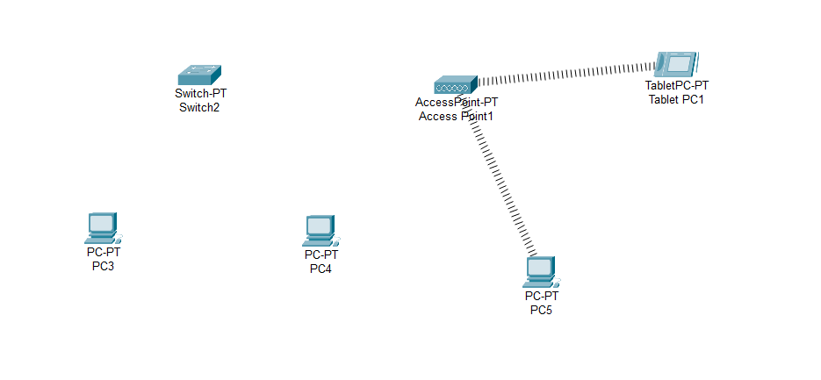

1. Then, Add the physical cabling between remaining devices to connect the devices using automatic cable so that it will look like this:

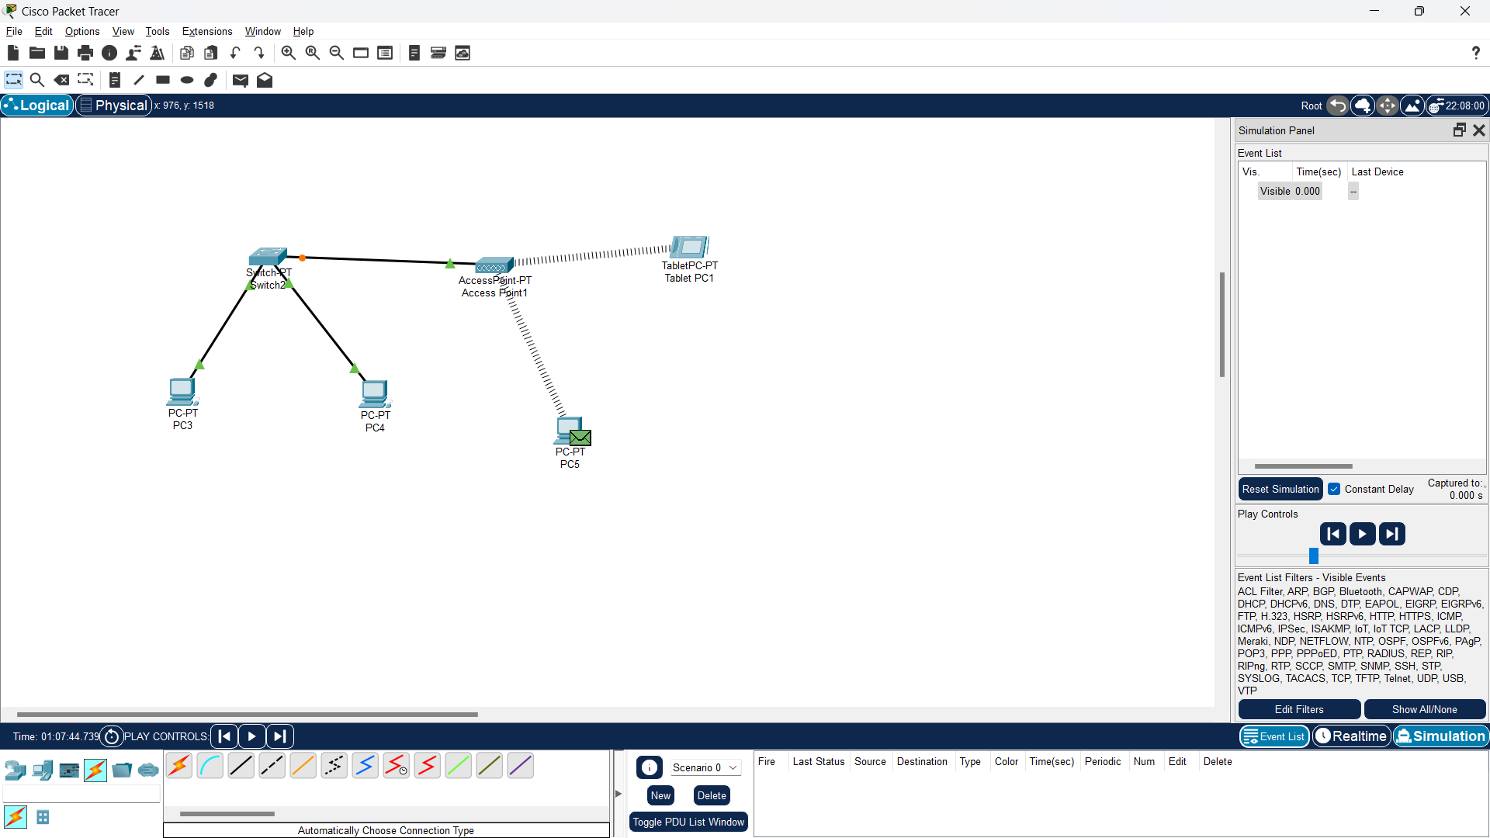

1. Then after the devices are connected physically and wirelessly, the next step is to configure the devices by providing IP addresses to all the PCs. In this way, “click PC3– Desktop – IP Configuration” and adjust the IP address for all PCs:

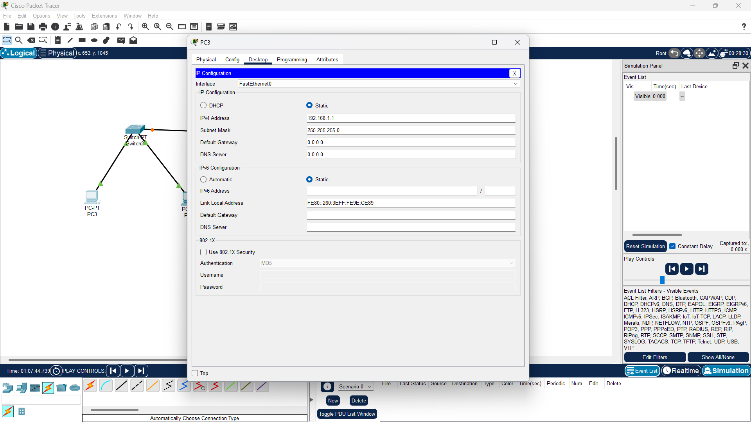

**Verification**: So, giving the IP address on all the computers will result in all computers being able to communicate with each other passing through different Network devices, we can test this by typing ping on one computer to the IP address on the other computers. For example, we will try to test the ping from PC3 (192.168.1.1) to TabletPc1 (192.168.1.4). To do a ping test we can use the Command Prompt on virtual computers (PC3 and TabletPc1), by clicking on one of the computers (PC3) then go to “Command Prompt” and type:

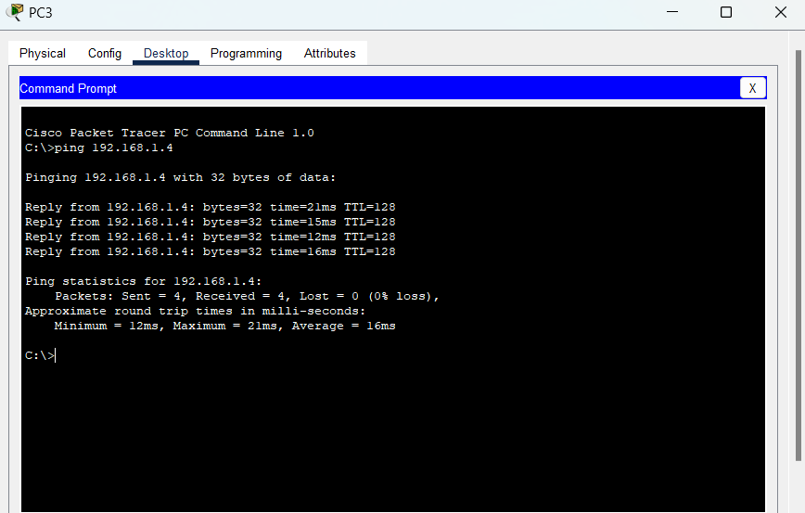

So, if indeed the computers are connected and can communicate with each other then TabletPC1 will send a response back with the message “reply from 192.168.1.4” which is a sign of success. However, if the process does not occur (timed out) on your display, namely 192.168.1…..you can change the host number as long as the hosts are different then the range of numbers that can be used is 1-255.

**CONCLUSION:**

In order to communicate computers in a WLAN, it share a common communications line to a server within a distinct geographic area.